TO: MASS Colleagues January 20, 2016
FROM: Dave Tobin, MASS School Finance
SUBJECT: Education Week’s 20th Annual Quality Counts Report released
Education Week has released its 20th consecutive Quality Counts Report. We are so proud to be associated with the leadership responsible for the administration of the Massachusetts public school educational delivery system grades Pk-12. Once again, Massachusetts’ schools top the nation on the measures of quality reported in this highly respected yearly report. For the complete report go to http://www.edweek.org/go/qc16
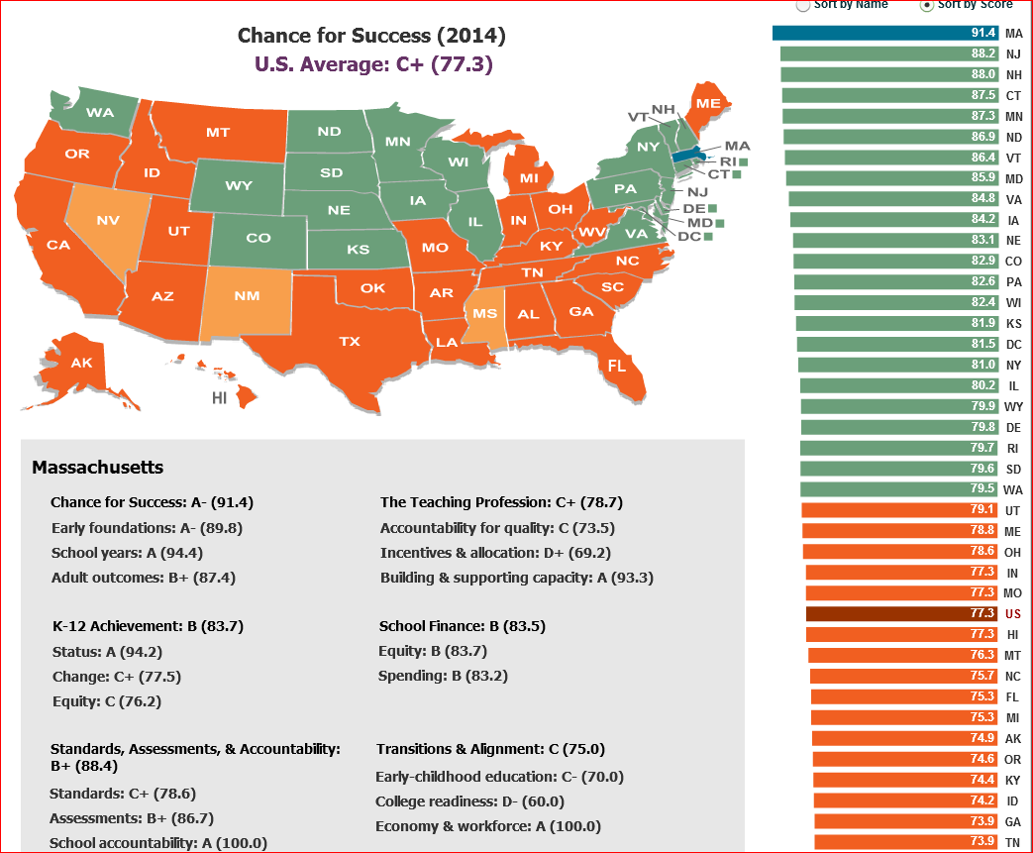
Summary of Highlights Annual Quality Counts Report, January 7, 2016
2016 Overall Grades Quality Counts
- U. S. Average C
- MASS B + (86.8) “For the second year in a row, Massachusetts finished first. Long a fixture of the top five, the Bay State best its own 2015 result, raising its grade from a B (86.2) to a B+ (86.8). Although New Jersey (85.1), Vermont (83.8), and Maryland (82.7) all received grades of B, Massachusetts was the only state to score B plus.”
Chance for Success Index: (Shown on the graphic above)
This index consists of 13 indicators that capture early opportunities, progress thorough the K-12 system and educational workforce outcomes in adulthood.
- U. S. Chance for Success Average C plus
- MASS A- (92.3) “For the ninth straight year, Massachusetts topped the rankings in this category. The state earned the only A- on the index. Connecticut (87.4), New Hampshire (89.1), New Jersey (88.1), Minnesota (87.4), and Vermont (86.8) posted grades of B-.”
K-12 Achievement Index
This index is “made up of 18 indicators capturing current academic performance, gains over time, and equity as measured by poverty-based disparities. Results on the index are based largely on National Assessment of Educational Progress scores…”
- U. S. Average C- (70.1)
- MASS B (85.2) “Massachusetts (85.2) continued its streak as the top-performing state for K-12 Achievement, earning the only B. It has been the leader in the rankings every year the index has been reported. New Jersey (81.0), the only other state with a grad higher than a C plus earned a B minus, this year…”
School Finance
“The school finance analysis examines school spending patterns and the distribution of funding across districts within each state.”
- U. S. School Finance Average C (74.6) National Average: $ 11,667 per pupil
- New York B+ (88.1) earned the nation’s highest score, Avg.: $ 17,291 per pupil
- MASS B Ranked 12th in School Finance, Avg.: $ 13,347 per pupil
Thank you to the students, staffs, school committees, parents and communities of the Commonwealth for their support as we together answer the challenge of “Every Child a Winner”.

