CITGO and the Boston Red Sox Team Up to Show Students Fun Ways to Learn About STEM (PRNewswire)
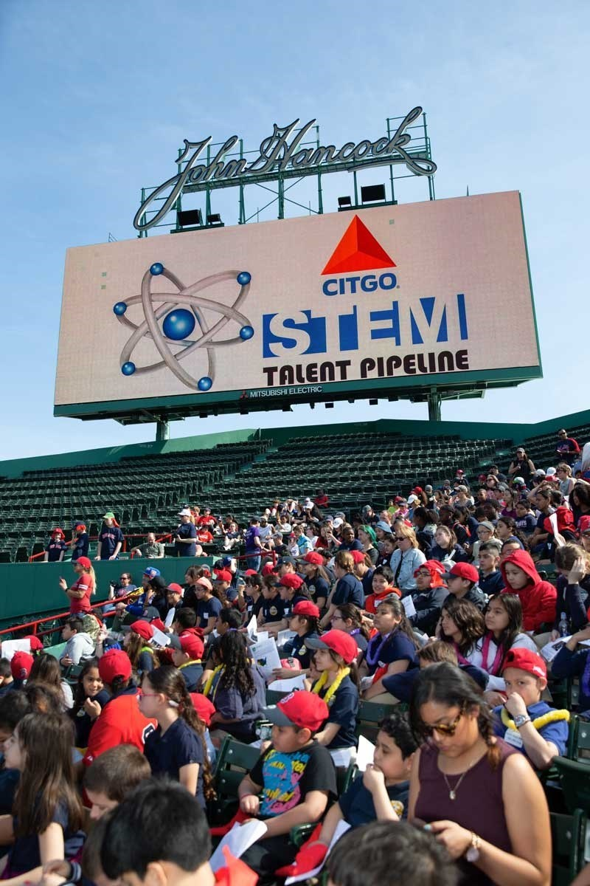
CITGO Petroleum Corporation and the Boston Red Sox are proud to team up to host two special STEM days showcasing the scientific principles that shape the world and America's pastime. In its second year, the "Red Sox STEM Education Days Presented by CITGO" at Fenway Park gives New England students, grades two through nine, the opportunity to learn about STEM in a unique environment and to enjoy a Red Sox home game. The first STEM Education Day, held on May 2, 2018, focused on science, weather and engineering. Pre-game activities included a STEM Fair with experiments from local organizations, an egg drop from the top of Fenway Park's historic Green Monster, and a fun coding challenge. The second STEM Education Day, scheduled for May 30, 2018, will highlight NASA and other important space initiatives.

