How to Meet the Strategic Challenge Posed by China
imprimis.hillsdale.edu/how-to-meet-the-strategic-challenge-posed-by-china/
David P. Goldman
Columnist, Asia Times

David P. Goldman is a columnist for Asia Times. He also writes regularly for PJ Media and the Claremont Review of Books and is the classical music critic for Tablet magazine. He has directed research at investment banks and served as a consultant for the National Security Council and the Department of Defense. A senior fellow of the London Institute for Policy Studies, he is the author of How Civilizations Die (And Why Islam Is Dying Too). In 2017, he was a Pulliam Distinguished Visiting Fellow in Journalism at Hillsdale College.

The following is adapted from a speech delivered on February 21, 2018, in Bonita Springs, Florida, at a Hillsdale College National Leadership Seminar.
China poses a formidable strategic challenge to America, but we should keep in mind that it is in large part motivated by insecurity and fear. America has inherent strengths that China does not. And the greatest danger to America is not a lack of strength, but complacency.
China is a phenomenon unlike anything in economic history. The average Chinese consumes 17 times more today than in 1987. This is like the difference between driving a car and riding a bicycle or between indoor plumbing and an outhouse. In an incredibly short period of time, this formerly backward country has lifted itself into the very first rank of world economies.
Over the same period, China has moved approximately 600 million people from the countryside to the cities—the equivalent of moving the entire population of Europe from the Ural Mountains to the Atlantic Ocean. To accommodate those people, it built the equivalent of a new London, plus a new Berlin, Rome, Glasgow, Helsinki, Naples, and Lyons. And of course, moving people whose ancestors spent millennia in the monotony of traditional village life and bringing them into the industrial world led to an explosion of productivity.
Where does America stand in respect to China? By a measure economists call purchasing power parity, you can buy a lot more with $100 in China than you can in the United States. Adjusted for that measure, the Chinese economy is already bigger than ours. In terms of dollars, our economy is still bigger. But the Chinese are gaining on us, and in the next eight to ten years their economy—unlike the economies of our previous competitors—will catch up.
China, on the other hand, is an empire based on the coercion of unwilling people. Whereas the United States became a great nation populated by people who chose to be part of it, China conquered peoples of different ethnicities and with different languages and has kept them together by force. Whereas our principle is E Pluribus Unum, the Chinese reality is E Pluribus Pluribus with a dictator at the top.
China once covered a relatively small geographic area. It took about 1,500 years for it to reach its current borders in the ninth century. These borders are natural frontiers. China can’t expand over the Himalayas to India, while to its extreme west is desert and to its east is the ocean. So China is not an inherently expansionist power.
Nor is China unified. It has a written system of several thousand characters that takes seven years of elementary education to learn, working four hours a day with an ink brush, ink pot, and paper. Learning these characters well enough to read a school textbook or a newspaper is how the Chinese are socialized. The current generation is the first where the majority of Chinese understand the common language, due to the centralization of the state and the mass media. But the Chinese still speak very different languages. Cantonese and Mandarin are as different as Finnish and French. In Hong Kong, you’ll see two Chinese screaming at each other in broken English because one speaks Mandarin and the other speaks Cantonese and they don’t have a word in common.
China is inherently unstable because all that holds it together is an imperial culture and the tax collector in Beijing. It is like a collection of very powerful, oppositely charged magnets held together by super glue—it looks stable, but it isn’t.
Within the living memory of older Chinese, China underwent an era of national division, warlordism, civil war, starvation, and degradation. The Century of Humiliation, as the Chinese call it—which began with the opium wars in 1848 and ended with the success of the Communist Revolution in 1949—was a century in which civil war claimed untold millions of lives, and the terror of a return to those conditions is a specter that haunts the Chinese leadership.
China, like Russia, responds to its past humiliation by challenging American power. It would be naïve to expect the Chinese or the Russians to be our friends; the best we can hope for is peaceful competition and occasional cooperation in matters of mutual concern. But it is also important to recognize that American policy errors exacerbate their suspicion and distrust. For example, our decision to impose majority rule in Iraq created a Shi’ite sectarian state now allied to Iran, and it left Iraq’s Sunni minority without a state to protect them. This drove the Sunnis into the hands of non-state actors and unintentionally helped al-Qaeda and ISIS. Sunni jihad is a serious security threat to Russia and China, and Russia’s intervention in Syria is, in part, a response to our mistakes.
The Chinese live a double life. If you walk down the street in Beijing, you see people who dress very drably, who show little emotion and do their best not to draw attention to themselves. But if you go to a Chinese wedding or a restaurant where families gather, the same people are loud and bumptious. Their real existence is a family existence. During the Lunar New Year, the Chinese have the largest migration in history—three billion long-distance journeys are undertaken—because all Chinese will travel long distances to be with their family.
Here in the West, we have a concept of rights and privileges that traces back to the Roman Republic—we serve in the army, we pay taxes, and the state has certain obligations in return. There is no such concept in China. Beijing rules by whim. The Chinese do whatever the emperor—or today, the Communist Party—asks, hoping they will be rewarded. But there is no sense of anything deserved. The idea of the state held together by a common interest as in Cicero, or by a common love as in St. Augustine, is unknown in China. The imperial power is looked on as a necessary evil. The Chinese had an emperor for 3,000 years, and when they didn’t have an emperor they killed one another. It’s all very well to lecture the Chinese about the benefits of Western democracy, but most Chinese believe they need the equivalent of an emperor to prevent a reprise of the Century of Humiliation.
From the standpoint of most Chinese, the Communist Party dynasty that took charge in 1949 has brought about a golden age. It’s the first time in Chinese history when no one is afraid of starving to death or of a warlord coming through and raping the women and burning the crops. So for the time being, the regime has a great deal of support, even though it is more comprehensively totalitarian than Hitler or Stalin could have imagined. As deplorable as the regime looks to us, the prospects for transforming China’s way of governance are for now negligible.
China’s Communist Party government is a merciless meritocracy, which is one reason the Chinese have difficulty understanding American politics. If you’re in the Chinese leadership, you made it there by scoring high on a long series of exams, starting at age twelve—which means you haven’t met a stupid person since you were in junior high school. The fact that democracies can frequently advance stupid people—we are entitled to do that if we wish—doesn’t make sense to the Chinese. The one thing President Xi Jinping cannot do is get his child into Peking University unless that child scores high on his exams. Here in America, you can buy your way into Harvard. You can’t do that in China. So while the Chinese Communist Party is not a particularly efficient organization, and is certainly not a moral one, it has a lot of incredibly smart people in it.
Along with ensuring internal stability at all costs, China’s leaders are determined to make China impregnable from the outside. We hardly hear the term South China Sea these days, because that sea has become a Chinese lake. It has become a Chinese lake because the Chinese have made it clear they will go to war over it. There’s a Chinese proverb: “Kill the chicken for the instruction of the monkey.” China has an even greater concern over Taiwan. The Chinese Communist Party is terrified that a rebel province like Taiwan can set in motion centrifugal forces that the Party will be unable to control. So the adhesion of Taiwan to the Chinese state—the imperial center—is for the Chinese government an existential matter. They will go to war over it. By demonstrating their willingness to fight over the South China Sea, they are demonstrating that they will fight all the more viciously over Taiwan.
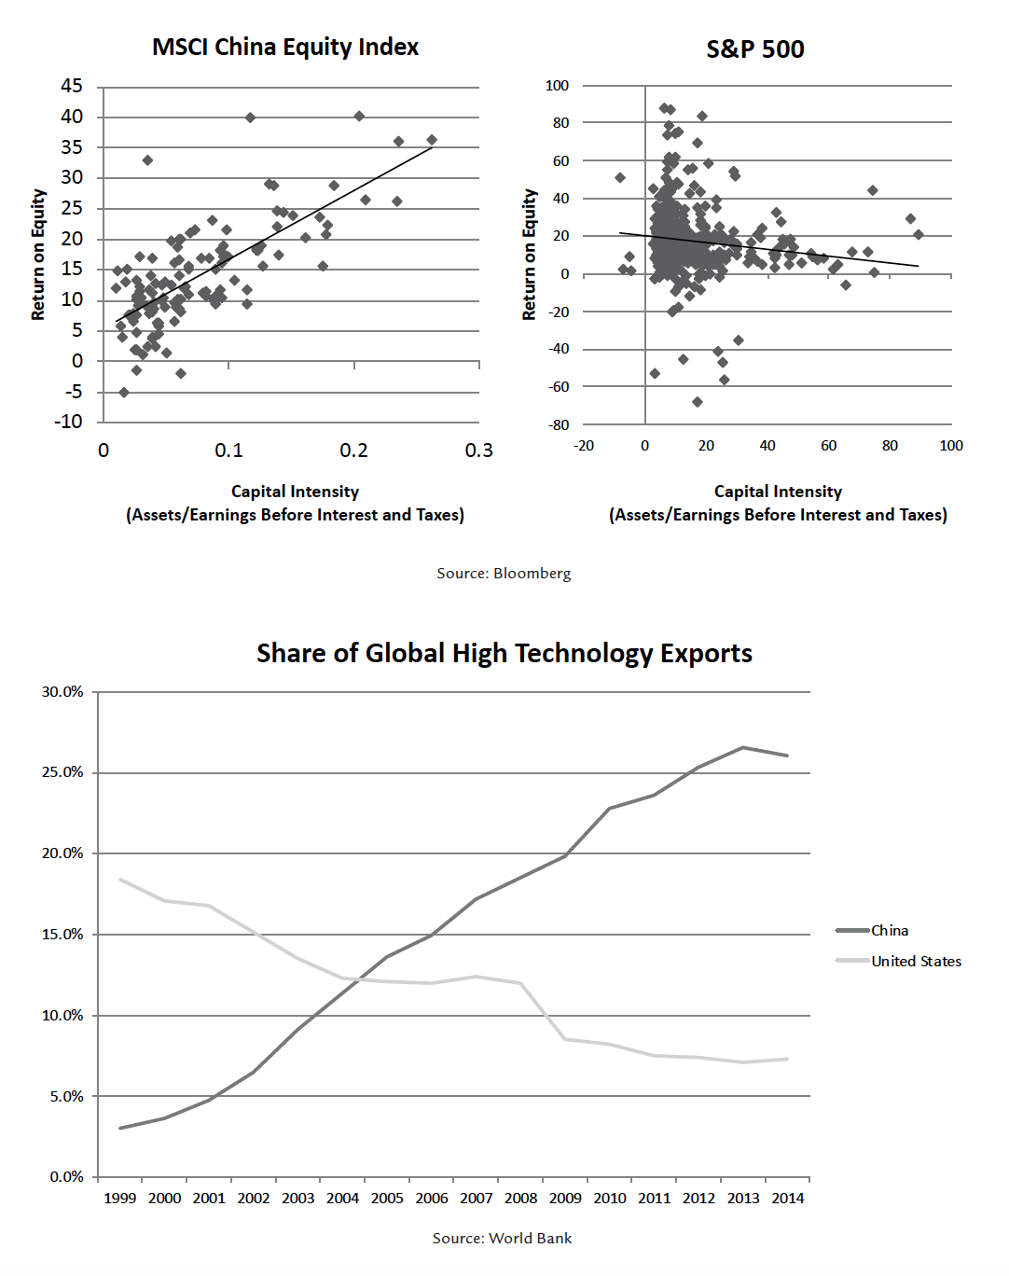
Turning back to our two economies, consider the three graphs above. China does something that Japan, Korea, and other Asian nations do—it massively subsidizes capital investment in heavy industry. From the Chinese standpoint, a steel mill or a semiconductor fabrication plant are public goods—the Chinese look at these things the way we look at highways and airports. And as a result of Chinese subsidies for heavy industry, America has been pushed out of any major capital-intensive manufacturing. Thirty years ago the Japanese were doing this, which is why the Reagan administration took steps to force the Japanese to build car plants in the U.S. But Japan’s economy was very small compared to ours. Because China’s economy is roughly the same size as ours, the impact of Chinese subsidies is huge.
The first graph shows the capital intensity of the companies in the major Chinese stock index (MSCI) versus their return on equity. The more capital-intensive, the higher the return. In the United States, on the other hand, if you look at the S&P 500 on the second graph, the slope is in the other direction. More capital-intensive industries are less profitable. This distortion of global investment by Chinese subsidies for heavy industry has led to a stripping out of capital from American heavy industry. It’s not that Americans prefer financial assets to real assets—it’s that the Chinese have pushed us out. That’s why we’ve lost so much ground in terms of industry.
As the third graph shows, China’s share of high tech exports has risen from about five percent in 1999 to about 25 percent at present, while America’s has plummeted from about 20 percent to about seven percent. That’s not a sustainable situation. What it means in practical terms is that America can’t build a military aircraft without Chinese chips. That’s a national security issue.
China’s “One Belt, One Road” policy, announced by President Xi in 2013, is a plan to dominate industry throughout Eurasia—both by land (belt) and by sea (road).
As a rule, so-called developing economies don’t develop, because 40 percent of the people are outside of the formal economy—they’re in the “underground” economy, mostly in small villages, and they live relatively unproductive lives. What the Chinese have done is to rip out the social structure of village life.
China’s economy is nothing like Japan’s, because Japan wanted to maintain its social structure. The Japanese protected agriculture, small retail, and small business. So in Japan we see a few great companies with global capacity sitting on top of a protected, inefficient economy. In China, which moved the mass of people from the villages to the cities, their equivalent of Amazon—Alibaba—will manage labor back in the villages. The Chinese have broadband everywhere, so as entrepreneurs figure out what villages can make, the villages will work for them.
The Chinese intentionally dismantled their social structure to avoid Japan’s constraints. And what they propose to do with “One Belt, One Road” is repeat that experiment throughout all of Asia—to Sinofy every country from Turkey to Southeast Asia.
A couple years ago, I visited the headquarters of Huawei, China’s telecommunications company—the biggest in the world—which hardly existed a dozen years ago. It has a campus that makes Stanford look like a swamp. Today it has 70 percent of the world market in telecommunications. How did Huawei do that? It cut prices and got massive subsidies from the government. After a three-hour tour, the Chinese sat the Latin Americans I was with down in a little amphitheater and said, “If you turn your economy over to us, we will make you like China. We’ll put in telecommunications. We’ll put in broadband. We’ll bring in e-commerce. We’ll bring in e-finance. You’ll be advanced like we are.” The Latin Americans didn’t take the deal, but the Turks have taken it.
Turkey plans to be a cash-free society in five years. Chinese telecommunications companies are rebuilding the Turkish broadband network. Turkey has given up on the West and is becoming the western economic province of China.
The impact of what China is doing is felt all over the world. Former allies of the U.S., including former NATO members, are orienting towards China. Russia—which has become totally dependent on China—has quadrupled its energy exports to China, providing China with land-based energy imports in case the U.S. tries interfering with seaborne energy traffic.
China has an extensive high-speed rail network, with trains going 200 miles an hour. This has had huge productivity effects, and the Chinese are proposing to build these trains all over Southeast Asia. Thailand, an agricultural country, sees that with high-speed trains built by China, it can become the source of fresh fruits and vegetables for China. So Thailand—which used to be an American ally—is being absorbed into the Chinese economy. And so on.
One of the most dangerous misconceptions Americans have about the Chinese is that they can’t innovate. Who do you think invented gunpowder, the magnetic compass, the clock, and movable type? Yes, China’s culture is much more conformist than ours. And on average, Chinese are less likely than Americans to be innovators. But there are 1.38 billion Chinese, and their research and development (R&D) spending is quickly catching up with ours. They’re producing four times as many science, technology, engineering, and mathematics (STEM) bachelor’s degrees and twice as many STEM Ph.D.s as the United States. Granted, some of them are of low quality—but many are excellent.
The single most troublesome deficiency we have in the United States is not the industrial base, which is relatively easy to deal with. It is the lack of scientific and engineering education. Six or seven percent of U.S. college students major in engineering. In China that number is 30-40 percent. That’s our biggest problem. Second to that is the fact, already mentioned, that there is a massive distortion of the global economic system caused by Chinese industrial policy.
The Chinese play very dirty. One of the issues raised in the Trump administration’s recent National Security Strategy is forced technology transfer. That is, if Intel wants to get access to the Chinese market—the biggest chip market in the world—China requires Intel to divulge everything it knows. From the standpoint of Intel stock price over the next five to ten years, that’s a pretty good deal. But it is bad from the standpoint of America’s national interest. If the U.S. government prohibits the transfer of technology to China, the Intels and the Texas Instruments of the world will scream, because it will hurt their stock prices. I’m a free trader, but national security sometimes supersedes the free market. This would be such a case.
Virtually all of American investment in R&D today goes to software. This means that we’ve conceded to Asia, and especially China, the actual manufacturing, to the point that—this bears repeating—we can’t put a warplane in the air without Chinese chips.
So what do we do about China? The answer is not to adopt an industrial policy. As Americans, we believe in individual liberty. We are not good at being collectivists. China and Germany have industrial policies. Culturally they can deal with it. We cannot. If we’re going to compete with China, we’ve got to do it the American way. And what we are best at is innovation.
In the 1970s, all the smart people thought Russia was going to win the Cold War. Economists at the CIA and in the universities believed that Russia had a great economy. But by 1989, we realized that the Russian economy was a piece of junk. It actually had a negative worth, because the cost of environmental cleanup exceeded the value of whatever Russia was producing.
What happened in the interim was the greatest wave of industrial innovation in American history. We invented fast, light, small, inexpensive microchips. We invented sensors that didn’t exist before. We invented the semiconductor laser. And we did virtually all of this through the Defense Advanced Research Projects Agency and NASA, in cooperation with the great corporate laboratories.
The U.S. turned the Russian economy into junk by creating an economy that hadn’t existed before. That was the Reagan economy. During this creation, the Fortune 500 lost employment. The monopolies were all ruined. New companies no one ever heard of sprang up to commercialize the new technologies, and corruption declined because we had challengers taking market share away from the entrenched interests.
In 1983, I wrote a memo for the National Security Council arguing that the Strategic Defense Initiative would pay for itself—that the impact of the new technologies we were researching, once they were commercialized, would generate more tax revenue than we’d spent on R&D. When you do R&D, you don’t know the outcome. Manufacturing using CMOS chip technology came about because the Pentagon thought it would be great for fighter pilots to have a weather forecasting module in the cockpit. The semiconductor laser came about because the Pentagon wanted to light up the battlefield during nighttime warfare. These technologies produced unforeseen consequences that rippled in unimaginable ways through our economy.
We have failed to continue this innovation in recent decades. Starting with the Clinton administration, we came to believe we were so powerful that we didn’t have to invest in national defense and new technologies. Investment went into the Internet bubble of the 1990s, as if downloading movies was going to be the economy of the future.
I’m a free marketer. But the one thing markets cannot do is divorce themselves from culture. It is when we have a national security requirement, forcing us to the frontier of physics to develop weapons that are better than those of our rivals, that we get the best kind of innovation. So the government has a role—a critical role—in meeting the Chinese challenge.
If the Chinese are spending tens of billions of dollars to build chip fabrication plants and we come up with a better way of doing it, suddenly they’ll have a hundred billion dollars’ worth of worthless chip manufacturing plants on their hands. But you can’t predict the outcome in advance. You have to make the commitment and take a leap of faith in American ingenuity and science. We can meet the strategic challenge of China, but we have to meet it as Americans in the American way.

