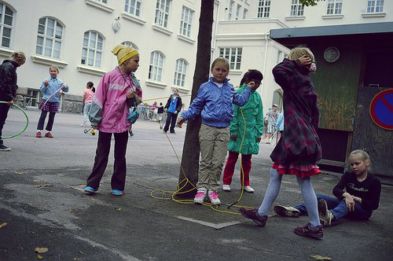
What do you learn when you take some of the United States' best teachers to a country that reportedly has one of the best education systems in the world?
Five state teachers of the year—representing Montana, Indiana, Nebraska, Colorado, and the Department of Defense Education Activity school system—spent three full days in Finland last month, where they visited the University of Helsinki and the Finnish National Board of Education. They attended several workshops and panel discussions on developments in the Finnish education system, including phenomenon-based learning, which prioritizes interdisciplinary, student-centered projects.
Finland's education system has long been touted as a model for successful education, as seen on its top rankings on international assessments (which have slipped in recent years). U.S. educators want to learn how to "teach like Finland," which is one of the happiest countries in the world and where students famously have 15 minutes of play for every 45 minutes of instruction. But some educators have pushed back against the love for Finland, saying that there are examples of education within our own borders that are just as successful.
After their time in Finland, the U.S. teachers traveled to Milan, Italy, for Education First's Global Leadership Summit, which was focused on the future of food and had celebrity chef Anthony Bourdain as one of the speakers. The teachers' travels were funded through scholarships by EF, an international educational tours company, and the Council of Chief State Schools Officers—recipients were chosen for their essays on becoming globally minded educators.
I spoke to two teachers—Jitka Nelson from Indiana and Amber Vlasnik from Nebraska—about their takeaways from their trip. You can also read the lessons learned from last year's cohort of teachers who traveled to Finland.
The Secret Key: Empowering Teachers
Nelson and Vlasnik said the teachers left with the impression that Finnish schools are doing a lot of the same things U.S. schools are: The major difference is that teachers are held in higher regard.
Teacher preparation programs are rigorous and selective, and there's only about a 10 percent acceptance rate, Nelson said. Because of that, teachers are not evaluated through standardized test scores.
Nelson said the Finnish belief is: "'You are the expert in the field, we do not need to test your kids to see how good you really are.' ... We don't have that in the States. It really undermines teachers' self-esteem."
And teachers in Finland have the autonomy to decide what and how to teach in their own classrooms.
"American teachers hesitate to say, 'oh, this looks good, let me try it,'" Vlasnik said. "That was one of my main takeaways: There's no secret to education, there's no secret formula that they're doing right and we're doing wrong, they're just trying new things and being innovative and giving teachers more power."
She said Finnish educational leaders believe "teachers know good instruction, we just need to let them do it."

See also: 'Our Society Trusts in Our Teachers': a Conversation With Finland's Ed. Minister

A Student-Centered Culture
Finnish students want to come to school and learn, Nelson said. Finnish teachers did not understand the U.S. teachers' question of how they handled student discipline, she said.
"It seems to be a cultural expectation of students to do well in school," Nelson said. "The two things I kept hearing from the Finnish people were the responsibilities of a citizen ... to one, take care of your body, and two, take care of your learning. Education is a lifelong event, and it does not only happen in school, and it does not end when schooling ends."
Of course, Finland doesn't have all the answers: Over a quarter of Finnish students have indicated that they are not happy at school and feel like they don't belong. And Nelson said she heard from a parent who wished teachers better handled disruptive student behavior, which does exist.
But Nelson said in Finland, the lifestyle, including students' views on schooling, is more relaxed and less competitive than in the United States. "The overarching goal of the education system is to inspire their students and enable them to live a happy, fulfilled life," she said.

See also: Joyful Schools: What One U.S. Educator Learned From Teaching in Finland

A Skills-Based Curriculum
Last year, Finland introduced a new national curriculum. It was created, for the most part, by former and current educators, said Petteri Elo, a Finnish teacher and educational consultant. In addition to the phenomenon-based learning element—meaning students are required to design and implement one interdisciplinary project each year—the curriculum is skills-based.
"The traditional teacher thinks content, content, content," Elo said. "But in Finland, we're supposed to think skills, skills, skills."
There are seven skills the curriculum is based on, including cultural competence, multiliteracy, entrepreneurship, and "thinking and learning to learn." Instead of being expected to cover certain content, teachers are expected to weave those skills into their lessons. It's not "content versus skills, but content with skills," Elos said.
It has required teachers to shift their frame of mind, Elo said. And Nelson said she had the impression that it was "causing a headache" for some Finnish teachers.
There is state-funded curriculum training for teachers, Elo said. But largely, teachers are trusted to implement the curriculum in their classrooms as they see fit: "We are professionals who can figure out ourselves how to implement it," he said.
Still, Elo said, the autonomy can be a "two-sided coin." Teachers in Finland don't have anyone checking in on their practice—and while that is powerful, Elo said it can cause problems if a teacher doesn't take the curriculum to heart. When Elo was in the United States as part of his Fulbright scholarship, he was fascinated by teachers' focus on fulfilling the curriculum as it was designed.
"If we could have that sort of intense concentration on being effective in the eyes of the curriculum, then Finland, with this amazing curriculum—teaching and learning in Finland would be amazing," he said.

See also: An American Teacher's Thoughts on the Finnish Education System

Lessons for the U.S. Classroom
Vlasnik and Nelson both said they left Finland with practical ideas to bring back to their own classrooms.
Nelson said she felt inspired by the focus on sustainability in Finland's curriculum.
"There is this coexistance of people and environments and nature," she said. "It seems like people are just there to take care of their body, take care of their learning, be participants in building a sustainable future. ... That is what is being instilled in the students from the get-go."
Nelson, who teaches English/language arts and English-language learners, said she will incorporate that concept and global learning into her classes more intentionally.
Vlasnik, who will be an instructional coach this year, said she will incorporate some of the Finnish philosophies into her practice—mainly using research when designing lessons. Finnish educators, she said, will take a research-backed practice, implement it on a small scale, and then scale it up.
Vlasnik said she will encourage her teachers to take a research-based strategy and see if it engages students in a meaningful way. "Is this impacting student learning? In what way? ... Was it just a fun activity that didn't engage students more than a traditional lesson? Why are we trying it? Be intentional," she said.
The educators said they left Finland thinking there were more similarities between the two educational systems than differences. But the Finnish system shows how powerful trust in teachers can be, they said.
"It is evident the value of teacher in their entire culture, and it's not evident in U.S. culture right now," Vlasnik said. "My goal is to change that in my own sphere of influence that I impact. How can I raise the teacher voice? How can I share what's happening [in our classrooms]? There's a lot of great things happening with our students, and we're being innovative and trying new things. ... I think I kind of went to Finland thinking, I'm going to feel kind of beat down, they're doing all these things right. They're trying things [we're trying], they're running into the same difficulties we do.
"We just need to tell that story."

See also: Some of America's Top Teachers Went to Finland. Here's What They Learned

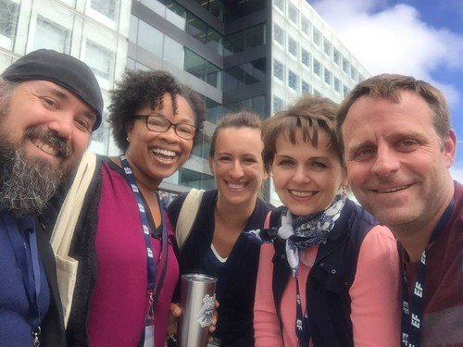
The five 2017 State Teachers of the Year pose in front of the Finnish education board headquarters. From left to right: Sean Wybrant (Colorado), Kelisa Wing (Department of Defense), Amber Vlasnik (Nebraska), Jitka Nelson (Indiana), and Kelly Elder (Montana).
Source: First image of Finnish children playing by Flickr user Sergey Ivanov, licensed under Creative Commons; second image courtesy of EF.

