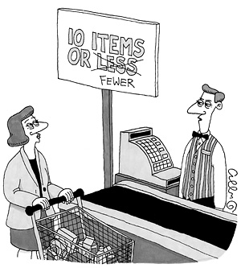

***"What can I say? I was an English major."***